To run docker from a file, you have to Identify the file path in which the Docker file is located

Docker files are called Docker

To build an image with a docker file, use docker build -t image_name:image_tag (optional) file_path

To run the built image is; docker run -it image_name

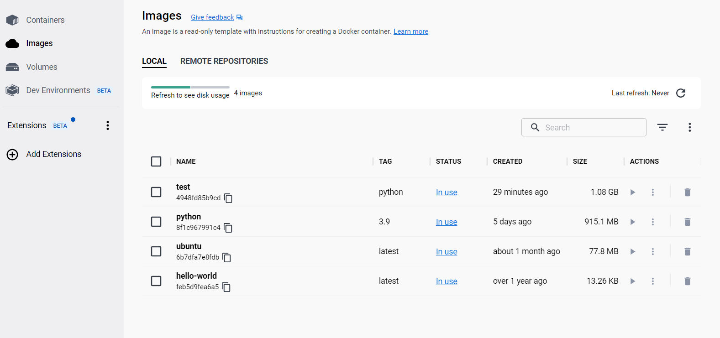

In a Docker file, the instructions are written in the order of execution.

Note: In docker file entry point is defined with “” and not ‘’. If ‘’ is used, you will get his error below.

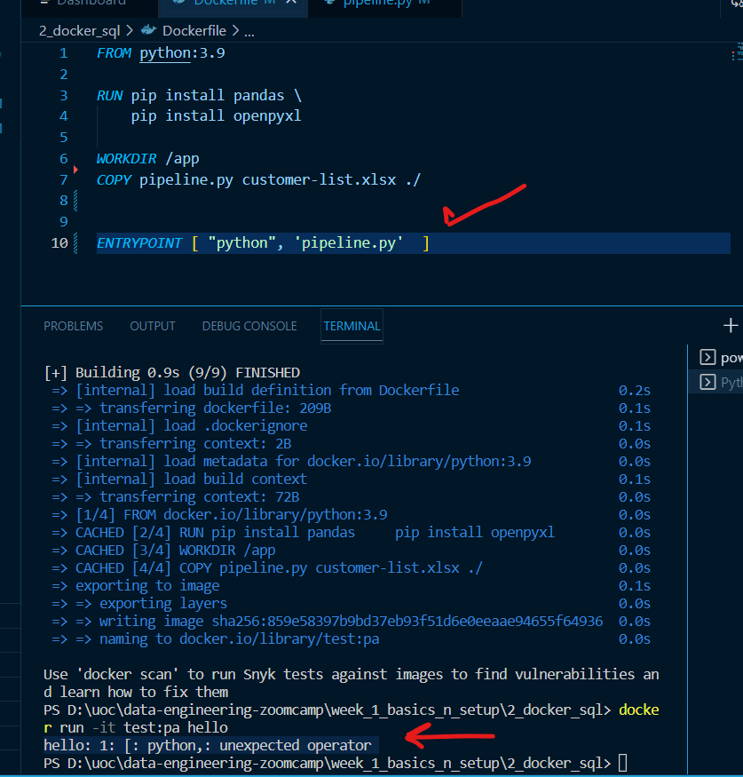

In docker, tags are used for versioning. Docker and DockerHub are like Git and GitHub

Docker pull repo_name is used to copy a docker file from docker hub

Docker ps : to view running processes

Docker ps -a: to view all processes running or stopped